Chapter 5, Solution 67.

Obtain the output v_{o} in the circuit of Fig. 5.94.

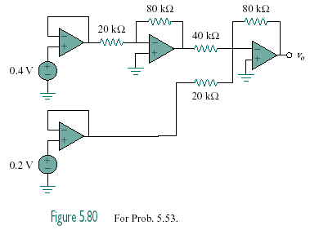

300 mV

700 mV

Figure 5.94
For Prob. 5.67.

Solution

v_{o} = = 2.4 – 2.8 = –400 mV.

